..Blind Eye..

**2 Players**

A game designed to be played with a high amount of random chance and low strategy input.

..Objective..

The end goal is to *obtain* the highest number of points after 9 rounds of gameplay. The game has been constructed so that a draw is not possible for the final score.

Each win is worth ***1 Point***

..Equipment..

1x Standard Deck of Playing Cards  
(Joker’s Removed)

..Setup..

*Shuffle* the deck of cards.

*Deal* 5 cards to the middle of the table in order of:

1st – Face Up

2nd - Face Down

3rd – Face Up

4th - Face Down

5th – Face Down

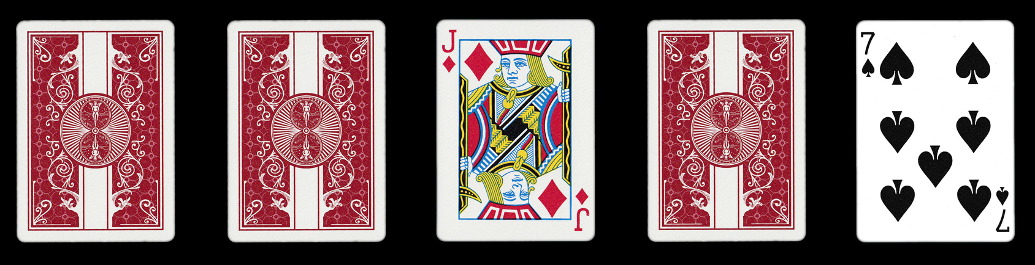

3rd

4th

2nd

1st

5th

..Setup..   
continued...

*Deal* 5 cards to each of the 2 players.

Player 2

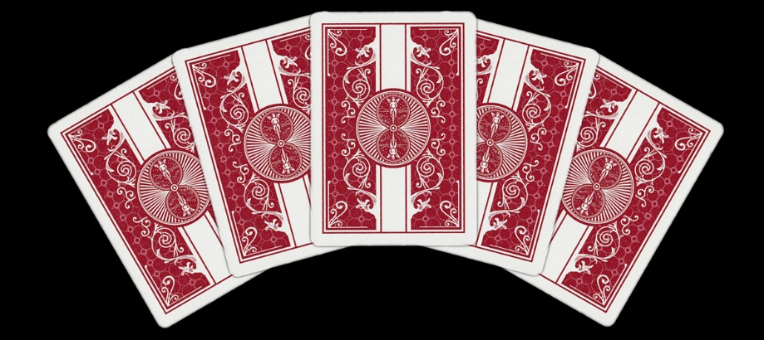

Player 1

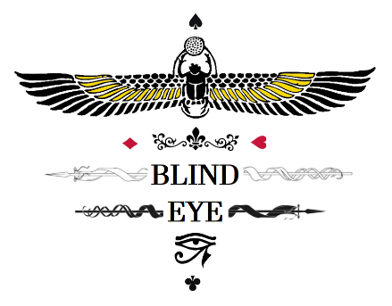

..Conditions..  
  
**Deck**

During normal gameplay, there is no hierarchy to the number value. This is with the intention of *finding* the player with the closest number *and/or* suit to the card in the middle of the table.   
(This does not apply when a *draw* occurs. \**See Draw Number Values Below*\*)

2 of Spades is 2 counts away.  
  
Hand Won

10 of Spades is 3 counts away.  
  
Hand Lost

**Suit Values**

**Clubs** – Lowest

**Diamonds** – 2nd Lowest

**Hearts** – 2nd Highest

**Spades** – Highest

**Draw Number Values**

**Ace** – Lowest

**King** - Highest

**..Scoreboard..**

|  |  |  |
| --- | --- | --- |
| Player 1 | ROUND | Player 2 |
|  | 1 |  |
|  | 2 |  |
|  | 3 |  |
|  | SHUFFLE |  |
|  | 4 |  |
|  | 5 |  |
|  | 6 |  |
|  | SHUFFLE |  |
|  | 7 |  |
|  | 8 |  |
|  | 9 |  |
|  | TOTAL |  |

..Starting The Game..

**First Turn**

Players must *decide* which cards in their hand will be the closest or matching value to the cards *placed* in the middle of the table. Only the **first 4 cards** will be *bet* facing down.

**Example Hand**

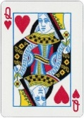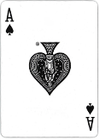

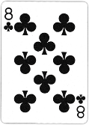

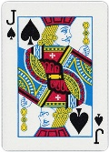

5th

4th

3rd

2nd

1st

**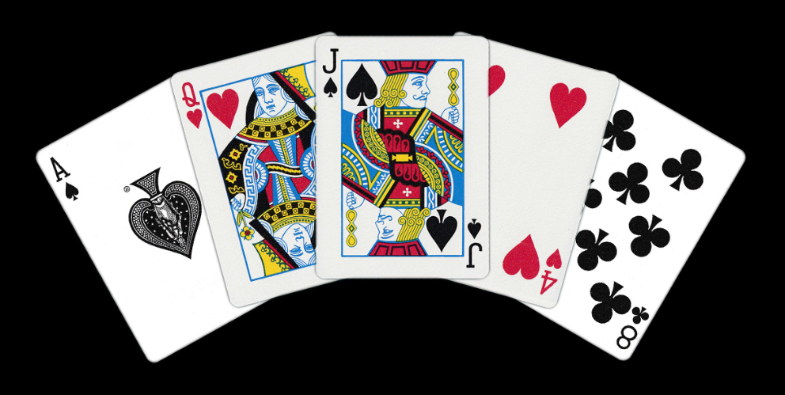****Example of Logical Play**

Player 1

1st **–** 8 **Clubs**

3rd **–** Jack **Spade**

2nd **–** Ace **Spade**

4th **–** Queen **Heart**

**Second Turn**

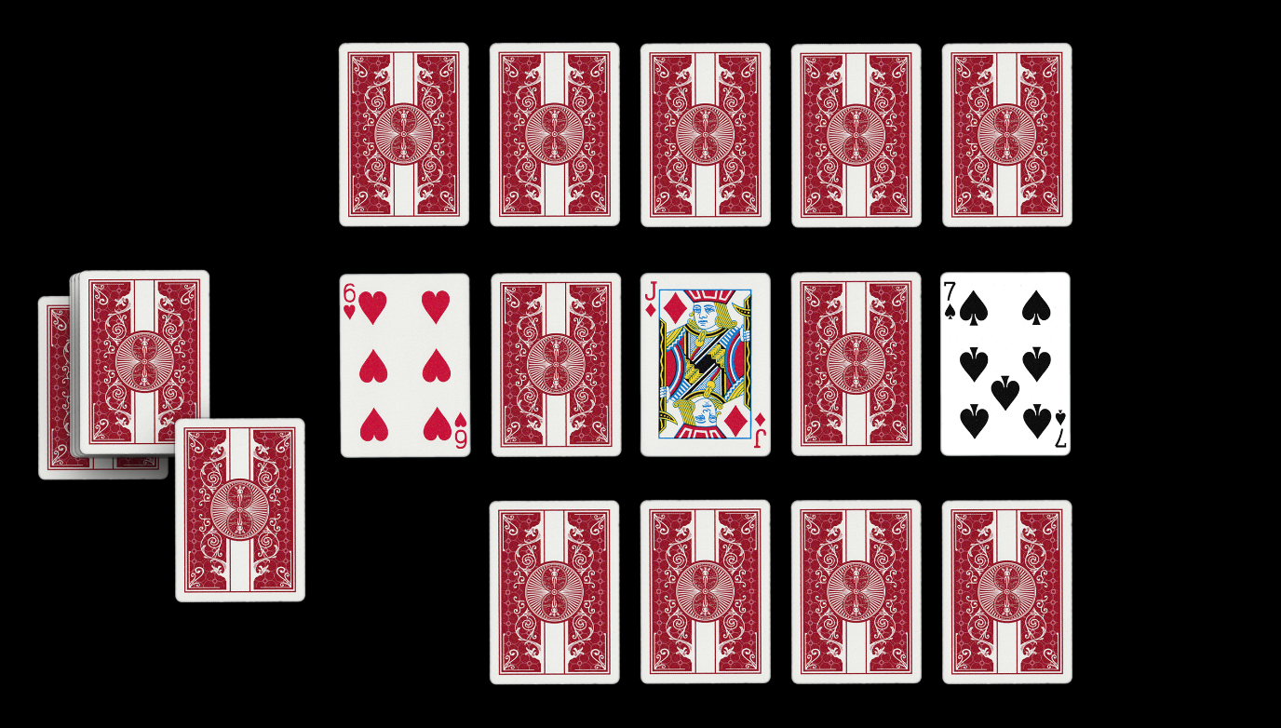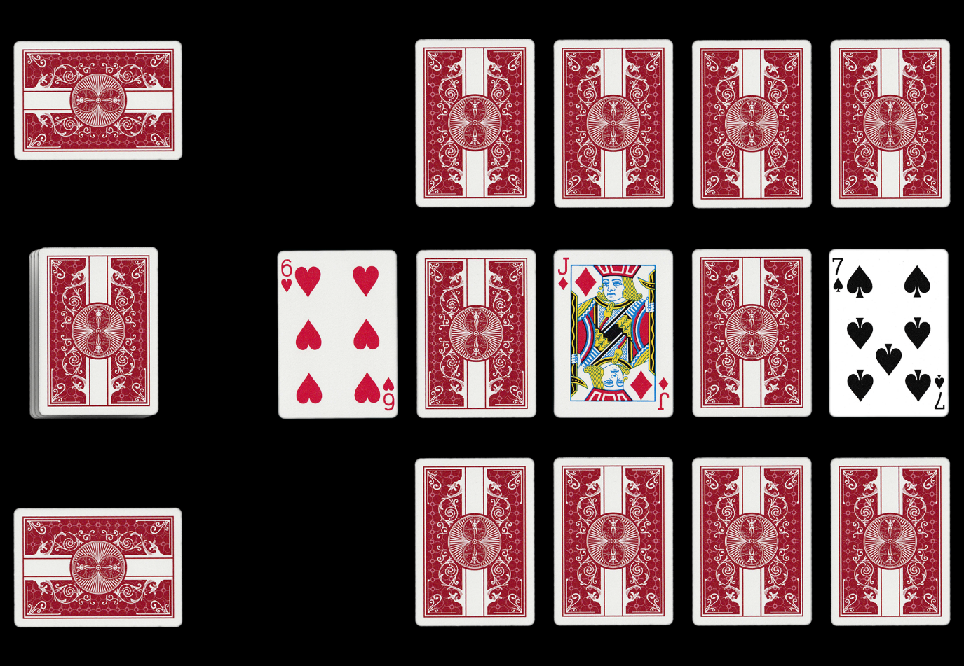The player who finishes *placing* their cards on the table last must *turn* over the 5th card once 4 cards from each player have been *bet* facing down.

2nd

Player 1 chooses to swap their 5th card.

Old Card

New Card

Deck

Each player now has the choice to keep their 5th card or return it to the bottom of the deck for a new card. This is called the ***Blind Eye***

5th

Player 2 Bets

Player 2 5th Card

3rd

4th

1st

Deck

Player 1 Bets

Player 2 chooses to bet their 5th card.

Player 1 5th Card

Player 2 Bets

If you choose to swap your 5th card, you may not *look* at the new card you pick up and must *place* it directly on the betting floor.

Player 1 Bets

Player 1 chooses to swap their card

**Third Turn**

*Turn* over the remaining 2nd and 4th cards on the table.

*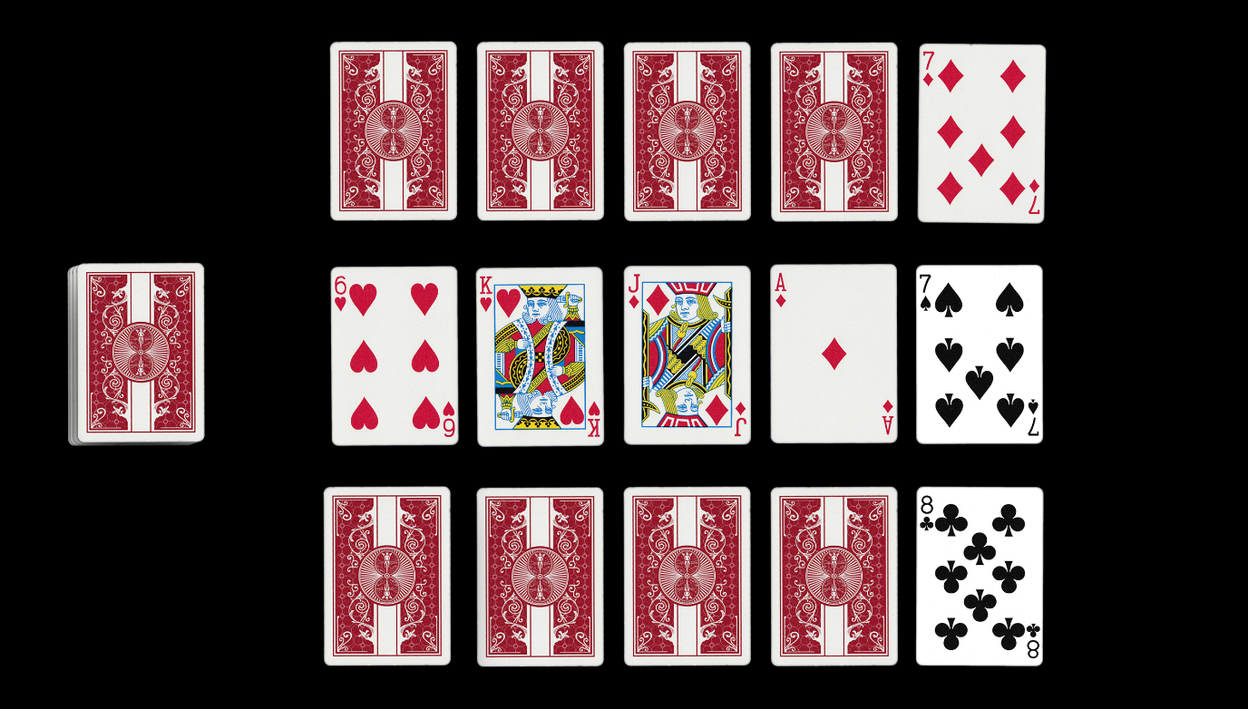Reveal* your 1st card to your opponent.

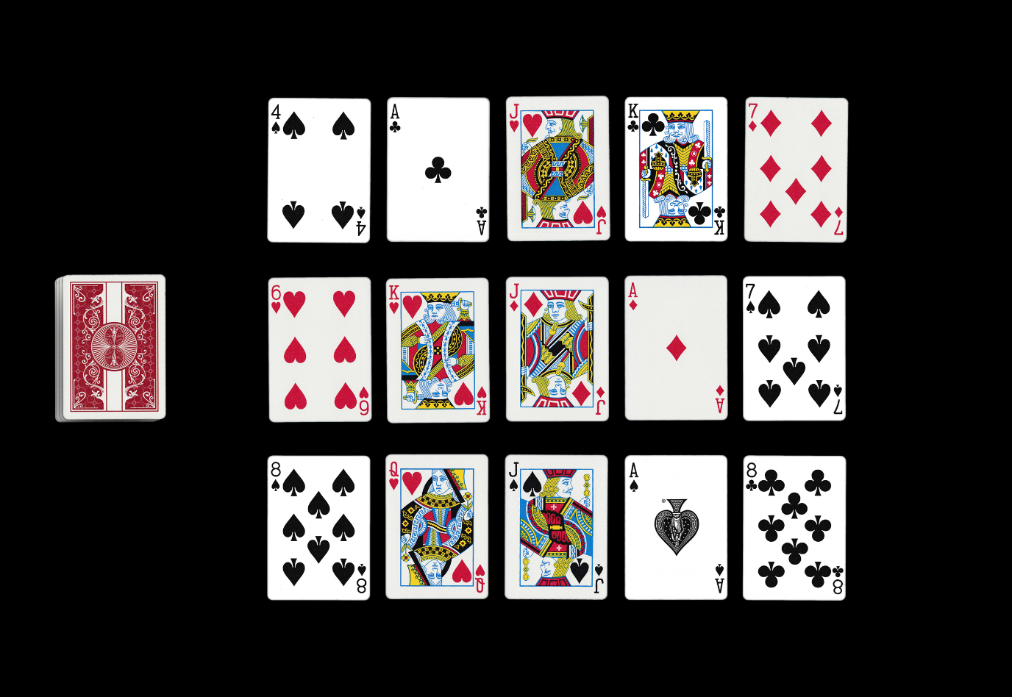

Deck

Player 1

Player 2

**Player 2 Wins 1st hand**  
*Matching number  
+  
Higher Suit*

5th

4th

3rd

2nd

1st

Deck

**Draw**

**Draw**

**Player 1 Wins**

**Player 1 Wins**

**Player 1 Wins**

**Player 2 Wins**

*Turn* over the remaining cards one at a time and *score* your values.

**DRAW**

If a draw occurs, *shuffle* the deck.

The player who won the previous hand gets first choice to pull from the **TOP** or **BOTTOM** of the deck. *(If there is no previous winner, flip a coin.)*   
  
**Example**

**Player 1 –** Bottom **Player 2** – Top  
**Player 1 –** Top **Player 2** – Bottom

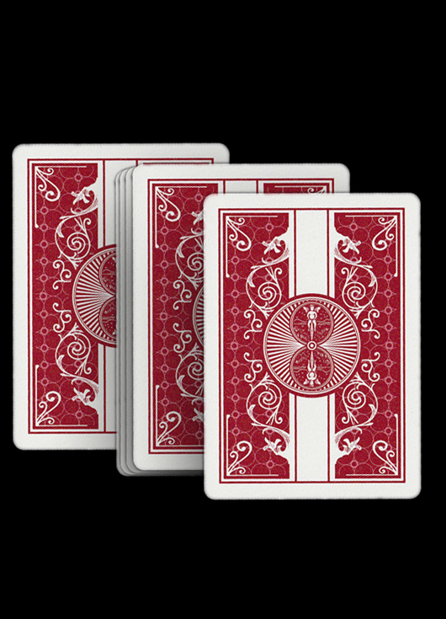

Player 1 won the previous hand and picks the TOP card

Player 2

Player 1

Player 2 must pick the BOTTOM card

The person with the highest number and/or suit wins the draw and claims the point.

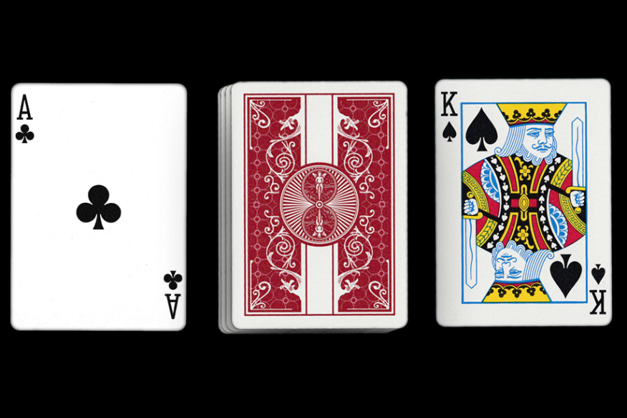

Player 2 draws the lowest suit and lowest value.

Player 1

Player 1 draws the highest suit and highest value.

Player 2

**Result**

**ROUND 1**

**Player 1 –** 4 Points  
**Player 2 –** 1 Point

|  |  |  |
| --- | --- | --- |
| Player 1 | ROUND | Player 2 |
| I I I I | 1 | I |



**Player 2 Wins**

5th

4th

3rd

2nd

1st

Deck

**Player 1 Wins**

**Player 1 Wins**

**Player 1 Wins**

**Player 1 Wins**

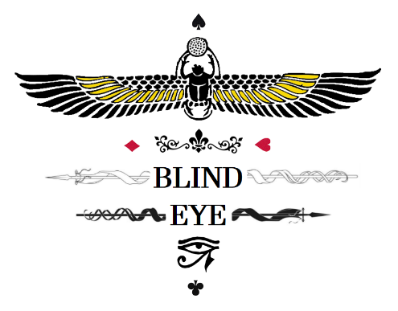*Return* all the cards on the table to the bottom of the deck and *deal* a new round.

..Winning.. ..requirements..

The player with the *highest total* after 9 rounds will be declared the winner.

**Example Scoreboard**

|  |  |  |
| --- | --- | --- |
| Player 1 | ROUND | Player 2 |
| I I I I | 1 | I |
| I I | 2 | I I I |
| I I I | 3 | I I |
|  | SHUFFLE |  |
| I I I I | 4 | I |
| I I | 5 | I I I |
| I | 6 | I I I I |
|  | SHUFFLE |  |
| I I I | 7 | I I |
| I I | 8 | I I I |
| I I I I | 9 | I |
| 25 | TOTAL | 20 |

**Player 1 is the winner!!!!!**

..Alternate Gameplay..

You can scale the difficulty of gameplay by adding or subtracting the number of cards delt to the player and the middle of the table.

**Minimal Difficulty –** 3 CARDS (FU1, FD2, FD3)

**Normal Difficulty –** 5 CARDS (FU1, FD2, FU3, FD4, FD5)

**Increased Difficulty –** 7 CARDS (FU1, FD2, FU3, FD4, FU5, FD6, FD7)

*FU = Face Up  
*FD = Face Down

..CREDITS..

*Levi Holmstrom  
&  
Danyelle Hayes*

***Game Concept:***